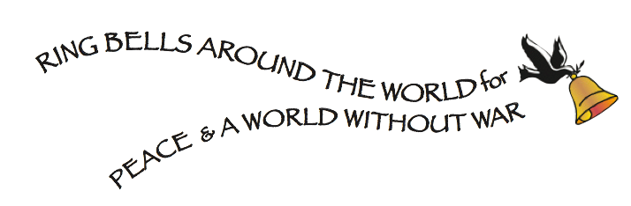

FOR IMMEDIATE RELEASE
July 21, 2015 contact: Andrew Kaen - 646-765-7890
andrewkaen@gmail.com

Join NYC and World Wide Churches
in ringing bells at the moment of the Hiroshima bombing
for Peace & A World Without War
Wednesday, August 5 th, 2015

WHAT: Share visions of peace & Bell RINGing Ceremony
Where: Strawberry Fields, Central Park – West 72nd Street entrance
WHEN: 6:30-7:30PM, Wednesday, August 5, 2015
7:15PM Peace Bell Ceremony and singing of Imagine
COST: FREE!

NEW YORK – On Wednesday, August 5th, join Universal Peace Day in a global event of ringing bells around the world for Peace and A World Without War at Strawberry Fields – in Central Park (enter West 72nd Street).The gathering is to commemorate the 70th anniversary of the dropping of the first atomic bomb on Hiroshima.

At 6:30pm, the public is invited share in Visions of Peace with poetry, dance and music. Artists from around the world will share their visions of Peace. This is a reunion bringing together performers, who have appeared at past UNIVERSAL PEACE DAY events over the last 31 years.

At 7:15pm (NYC time), the exact moment of the Hiroshima bombing (8:15AM August 6 in Japan), there will be a Peace Bell Ringing ceremony –followed by a minute of prayers for peace and then singing of John Lennon’s Imagine. All are invited to ring bells

As in past years, bells will ring around the world including Japan, New Zealand, Egypt, Iran, Iraq, Pakistan, Nigeria, Mexico, U.S. and New York City churches including Trinity Church, The Riverside Church, St John the Divine, St. Barts, Grace Church, St John’s Lutheran Church, and Middle Collegiate Church. To see a map of places that rang bells in 2014, go to: http://bit.ly/map_of_Bells.

Universal Peace Day brings people around the world together to share their vision of peace and to transform a remembrance of horror into a rededication of life. The legacy of Universal Peace Day, sponsored by Art For The People, began in 1984 in Central Park, where Peter Yarrow of Peter, Paul and Mary performed before a candle lighting ceremony at the moment of the Hiroshima bombing. Over the years, Universal Peace Day events have taken place in numerous NYC locations including Dag Hammersjkold Plaza, Riverside Park, Battery Park, The Riverside Church, Church Center of the UN, Church of St. Paul and St. Andrew, and the NY Buddhist Church.

For more information contact: Andrew Kaen – 646-765-7890 • andrewkaen@gmail.com www.facebook.com/ringbells4peace • @ringbells4peace •

###

